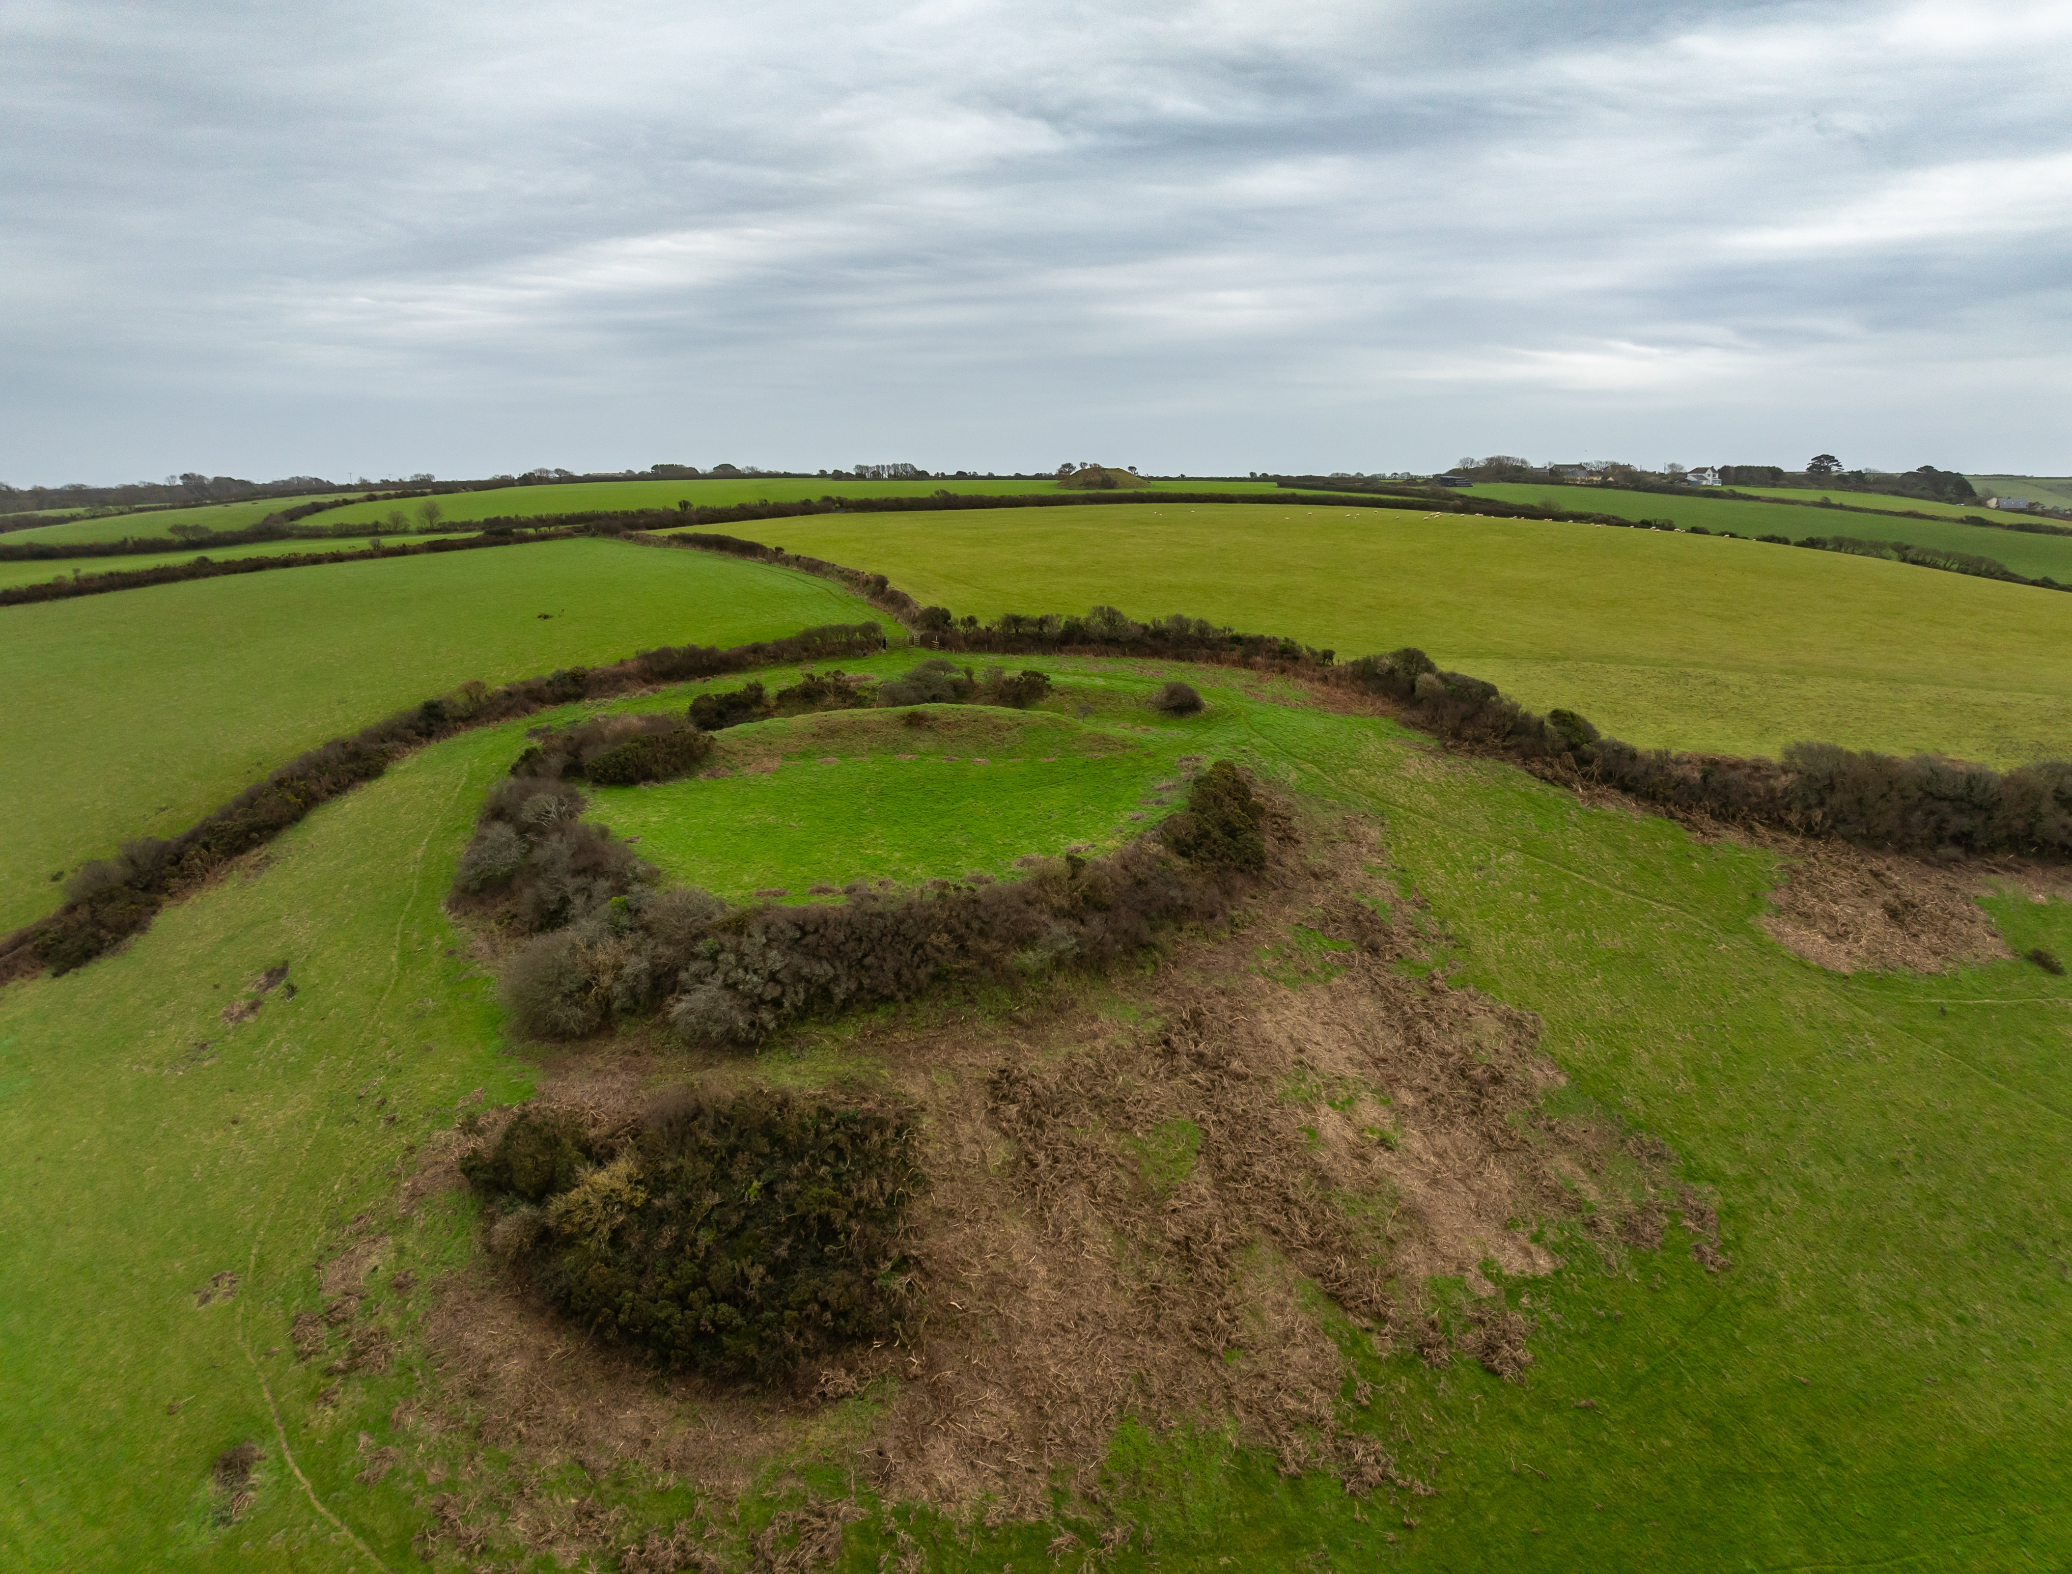

Veryan Castle Management Plan
A Monumental Improvement Project
Cornwall National Landscape
September 2025


A Monumental Improvement Project:

The Monumental Improvement Project was delivered by Cornwall National Landscape between 2022-2025 and sought to ensure that 40 at risk and vulnerable Scheduled Monuments, spanning 6000 years of Cornish history, were better identified, supported and enjoyed by a wide range of people.

The Project was funded by The National Lottery Heritage Fund (NLHF), Cornwall Council, Historic England, National Trust, Cornwall National Landscape (including Farming in Protected Landscapes Funding), Cornwall Heritage Trust, Cornwall National Landscape Trust.

The Project was supported by a Partnership Board, made up of representatives from Cornwall National Landscape, Historic England,
Cornwall Archaeology Society, Cornwall Heritage Trust, National Trust and Cornwall Council.

A Lasting Legacy:

The Purpose of this document is to provide advice and guidance on the future management of Veryan Castle. This management plan has been put together by the Monumental Improvement project and informed by the Partnership Board.

This document references the Toolkit for Volunteer Monitoring and Maintainance at Heritage Sites, designed to be used by landowners and volunteer groups in carrying out ongoing monitoring and maintenance, including a methodology approved by Historic England, ecological considerations, statutory designations, a reporting framework and risk assessment.

The Toolkit and resources including archaeological, ecological and management information, can be found on the site-specific webpages on the Cornwall National Landscape website.



Veryan Castle
Management Plan

Contents
Site Overview 3
Designations 4
Visiting & Contacts 5
Monumental Improvement Interventions 6
Management & Maintenance Recommendations: 7
Ongoing Site Management Recommendations: 7
Putting recommendations into practice: 7
Future Opportunities: 8
Ecology Overview 10
Archaeological Overview 12
Risk Assessment 13

Site Overview

(Use this information when completing HER Monument Monitoring and Recording form)

Site Name: Veryan Castle
Scheduled Monument Number: 1019746
Site Type: Hillfort
Site Grid Reference: SW 90927 38786
Site W3W: palm.arrival.shepherdess
Site Postcode: TR2 5LW
Details:
Veryan Castle, or the Ringarounds, is an Iron Age or Romano-British defended site defined by an enclosing rampart and ditch with traces of a second and third rampart on the south-eastern side.

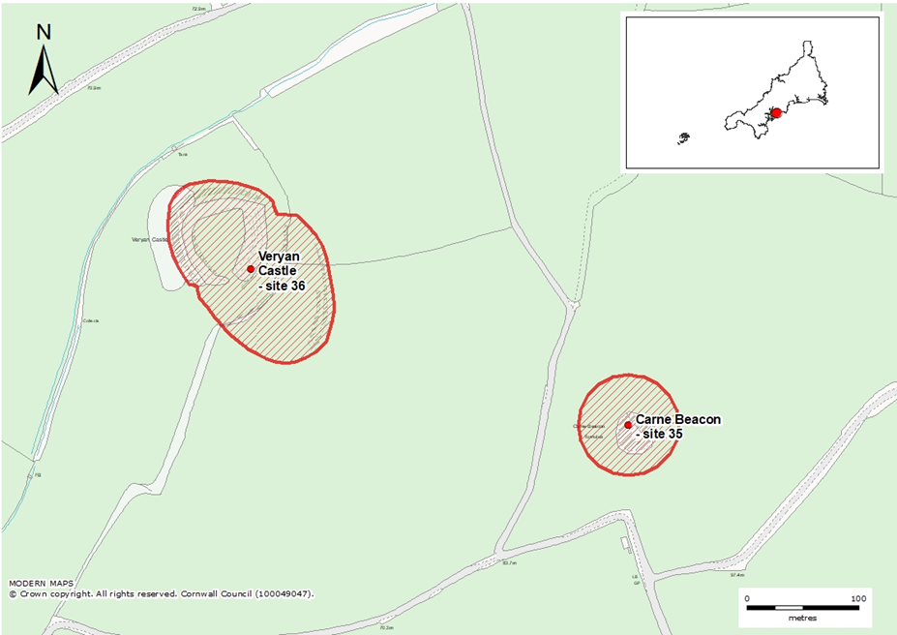

Designations

HE Designations: Scheduled Monument.
Other Designations: Cornwall National Landscape – Section 9 – South Coast Central and a Heritage Coastline
Site Status on HAR register (July 2025): At Risk

Link to CIOSHER web page for this site:
https://map.cornwall.gov.uk/website/ccmap/?zoomlevel=7&xcoord=213191&ycoord=77654&wsName=CIOS_historic_environment&layerName=Scheduled%20Monuments

Link to Historic England’s webpage for this site:
https://historicengland.org.uk/listing/the-list/list-entry/1019746?section=official-list-entry

Link to Cornwall National Landscape webpage for this site:
https://cornwall-landscape.org/monument/veryan-castle/



Visiting & Contacts

Landowner (s): National Trust
Main Contact: Harriet Wherry, Lead Ranger, Roseland
E:mail: harriet.wherry@nationaltrust.org.uk
Secondary Contact: Jim Parry, National Trust Archaeologist
E:mail: james.parry@nationaltrust.org.uk

Site Specifics -
Nearest Volunteer Tool Hub & Contact: Tehidy Country Park
Relevant Volunteer Organisation: Cornwall Archaeological Society
Contact: Tool Hub contact: countrysideservice@cormacltd.co.uk
Tool Use: Hand tool only
Parking for site: Park considerately and carefully in Carne Beach National Trust Car Park see X in map below. NT members park for free (scan card at machine) NGR: SW 90553 38352 W3W: waiters.gurgling.divide
OR
In layby in lane between Veryan and Carne Beach carpark
NGR: SW 91009 39049 W3W: clicker.skill.disband

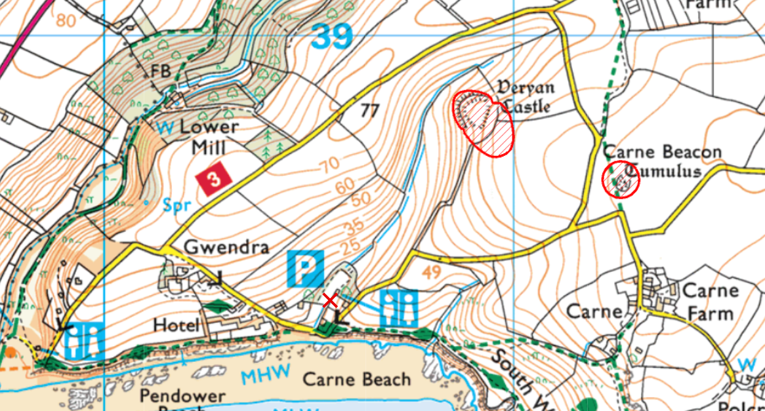

Monumental Improvement Interventions

Site priorities identified during Monumental Improvement Development Stage:

Priority | Project year | Action
Longer term | 3 (post project) | Monitoring of conservation work by volunteers.

Vegetation management | Interpretation | Survey & Monitoring
To be carried out/ co-ordinated by National Trust rangers and NT volunteer groups. | Landowner to check and report to Cornwall National Landscape on any issues | Monument Watch or HART monitoring through CAS or local community groups/ and NT ranger-led volunteer walks.

Threats to the site:

- The principal threat to Veryan Castle is the densly overgrown scrub including bracken, gorse and bramble.
- The badger survey has revealed active setts (CEC 2021) although these do not seem to have caused significant disturbance.

Interventions during Monumental Improvement Delivery Stage:

- A condition survey was undertaken out in 2021 by Cornwall Archaeological Unit, identifying threats to the monument and proposing a range of interventions aimed at enhancing the condition of the site and raising its profile with the local community.
- An ecological survey of the site was completed in 2021 by Woodfield Ecology, identifying habitat types and compiling an inventory of notable species to inform future conservation and land management plans. Also, a further badger survey was completed in 2024.
- A geophysical (magnatometry and resistivity) survey of the site was undertaken by South West Archaeology in 2023.
- Future management principles in this document were proposed based on conversations between the National Trust Archaeologist and the Monumental Improvement project team over the course of the project.
- Relevant Volunteer Organisation(s) have been engaged and supported throughout the Monumental Improvement Project. Volunteers have received hand tools safety training to assist in the future management of the site as part of the legacy programme.

Assets created during Monumental Imrprovement Delivery Stage:

- New site-specific webpage hosted on the Cornwall National Landscape website.
- New digital interpretation including a site overview, ecological information, surveys and reports.
- Aerial photography of the site captured by drone showing the archaeological features in plan.
- Ground Photography of the site, recording conditions of the monument and its setting in the landscape.
- Creation of the Toolkit for Volunteer Monitoring and Maintenance at Heritage Sites to assist in the future management of the site
- New on-site physical interpretation with a QR code for more information on the Cornwall National Landscape website.

Management & Maintenance Recommendations:

Ongoing Site Management Recommendations:

- Targeted scrub clearance of the ditches and banks of the enclosures, including the field boundary whilst avoiding clearance of the active badger set on the west side of the monument.
- Condition monitoring of the field boundary to the NE of the site which has high archaeological potential.
- The badger survey to be periodically updated.
- The landowner to use MI assets as interpretation tools to raise the profile of the monument, for example social media, print and the NT website.

Putting recommendations into practice:

- Please refer to the Toolkit for Volunteer Monitoring and Maintainance at Heritage Sites for a best-practice guide to carrying out scrub clearance and monitoring work at heritage sites.
- All site work must be accompanied by a Risk Assessment covering all attendees and activities.
- A record of work should be made and a copy sent to the secretary of the Relevant Volunteer Organisations: e.g. Cornwall Archaeological Society, Historic England and Historic Environment Record (HER). You can find a template for your records and a link to the HER online form in the Toolkit for Volunteer Monitoring and Maintainance at Heritage Sites.

Future Opportunities:

- A grazing regime to be agreed between the landowner and tenant farmer covering the interior of the monument and surrounding field with reference to the geophysical survey.

Vegetation/scrub clearance methodology:

Please refer to the Heritage Sites Monitoring & Maintenance Toolkit for a best-practice guide to carrying out scrub clearance and monitoring work at heritage sites.

For site-specific considerations, please refer to the section below.
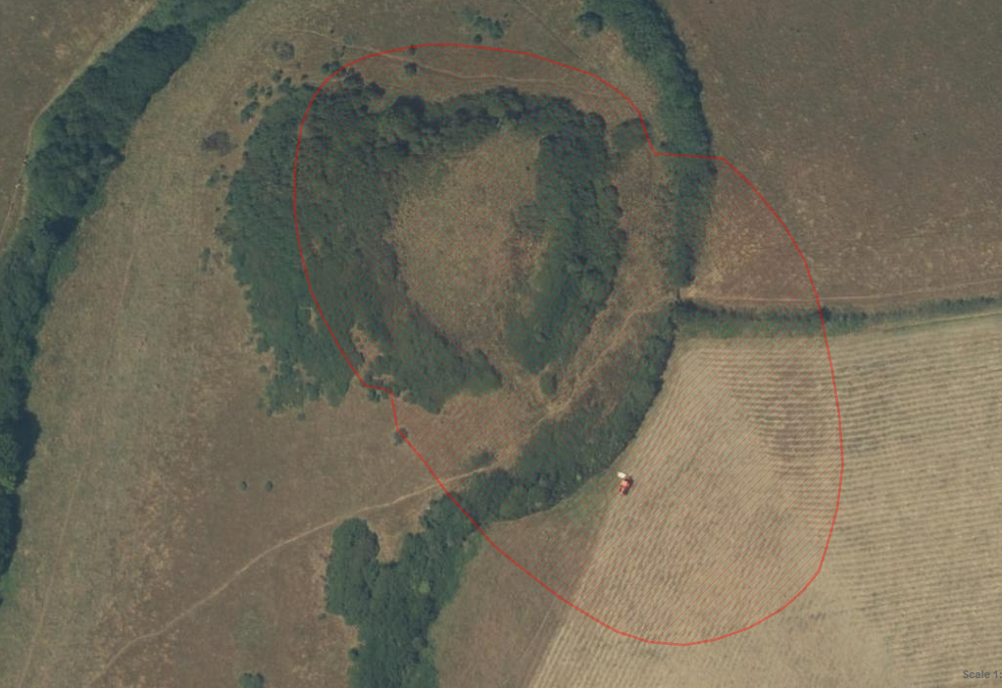
1Satalite image of Veryan Castle with scheduled area in faint red

Site-Specific Management Considerations:

All work at Veryan Castle should be facilitated by and overseen by the National Trust as landowner to ensure consistent and targeted clearance of the monument.

Due to the presence of badgers, a protected species in active sets at the monument, vegetation should be left standing on the west side of the monument (shaded yellow). By maintaining this habitat, and carefully managing the vegetation across the rest of the site we can mitigate some of the damage from the badgers burrows, and limit how wide spread the set extends, as the badgers will prefer to live in the most vegetated areas of the site.

Hand tools should be used to remove vegetation on and between the ramparts and arisings should be dealt with by the National Trust ranger in accordance with their own policies.

The condition of the field boundary should also be monitored for damage or slippage of the stonework as there is high potential for surviving archaeology related to the scheduled monument.

Any changes in the condition of the monument should be reported to the National Trust through the ranger team.

Please refer to the hand tools training information and video as well as the Historic England guidance for working on Scheduled monuments here (https://historicengland.org.uk/advice/technical-advice/monuments-and-sites/) for information on how to remove vegetation without damaging the above or below ground archaeology.

Ecology Overview

Taken from: ECOLOGY BRIEFING NOTE – Site 36 Veryan Castle. Commissioned by the Monumental Improvement Project in 2021.
The full Report is available to download on the Cornwall National Landscape website and includes details on types of work likely affect the following species, a calendar for helping to plan work at the monument, and opportunities for ecological enhancement of the site.

Key species at this site:

Birds | Reptiles | Flora | Mammals
Common Scoter | Adder | Shore Dock | Badger
Purple Sandpiper | Common Lizard
Slavonian Grebe
Velvet Scoter
Common Scoter
Cornish Chough
Mediterranean Gull
Yellowhammer
Dunnock

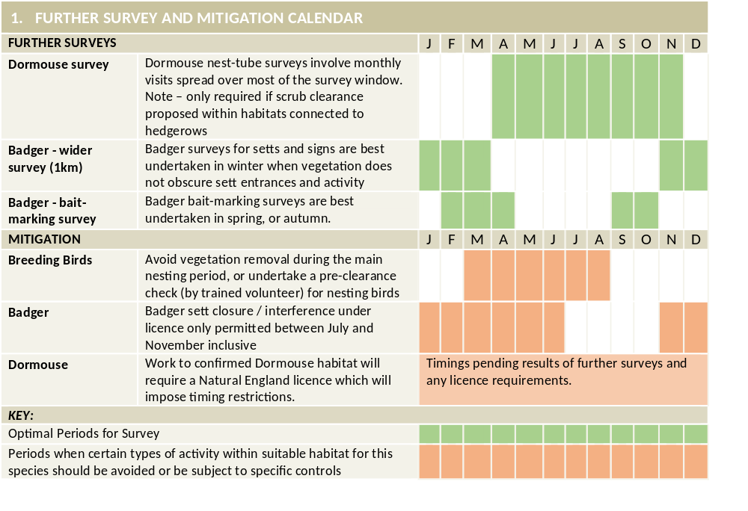

Archaeological Overview

Veryan Castle, or the Ringarounds, is an Iron Age or Romano-British defended site defined by an enclosing rampart and ditch with traces of a second and third rampart on the south-eastern side. The site stands on the slope of a steep hill; to the west the ground falls steeply, but the interior is nearly level, and the rampart is highest on the poorly defended south-eastern side; on the north-west it is hardly visible.

The fort has an inner enclosure, egg-shaped in plan, with a concentric outer enclosure on the south and east sides, and a crescentic annexe beyond this, the whole being sub-oval in plan and measuring approximately 180m north west-south east by 130m north east-south west.

The inner enclosure, measuring 60m north-south by 42m east-west internally, is levelled into the slope by cutting in on the uphill side and building out downhill.

On the east side it has an enclosing bank approximately 6m-8m wide and 6m high, formed by an earth and stone rampart above the scarp cut to level the enclosure, with an external ditch 2.2m-4m wide at its base and around 4m deep.

On the west side the enclosure is defined by a scarp up to 7.5m high, having no visible inward facing bank, but with a terrace around its base 3m-4m wide and sloping slightly outwards, considered to be a silted external ditch, above a very steep natural slope.

An original entrance from the outer enclosure to the south-east is visible as a gap some 6m wide on the south side, between the bank on the east side and the scarp on the west side.

The outer enclosure of the fort, surrounding the inner enclosure on the south and east sides, measures up to 25m across and slopes west with the natural gradient.

A boundary bank of earth and stone with stone facing, relatively recent in its present form, is considered to incorporate remains of the rampart around this enclosure.

The northern part of the boundary bank is 2m wide and 2m high inside, 1.5m high outside, and has an external ditch 2.6m wide and up to 0.6m deep. On the south-west side the return to the inner enclosure is formed by a scarp some 6m across and 2m-3m high.

The original entrance to the outer enclosure is considered to be on the south side, where it is approached by a hollow way. The annexe adjoining the fort to the south-east has an enclosing bank visible on the ground as a scarp around 12m across and 0.7m high, with traces of an external ditch.

Risk Assessment

Before any work takes place, a comprehensive Risk Assessment should be created. A template has been prepared for work carried out at this site and should be updated for future events – with any new risks considered. The template can be found on the Cornwall National Landscape website and with the Relevant Volunteer Organisation.

Some key issues which should be included in a risk assessment:

- Uneven ground including large holes and badger setts.
- Remote location with intermittent phone signal.

NB: This is not an exhaustive list and individual circumstances of each group and site conditions should be considered in creating a risk assessment.
Report No: 2021R045

