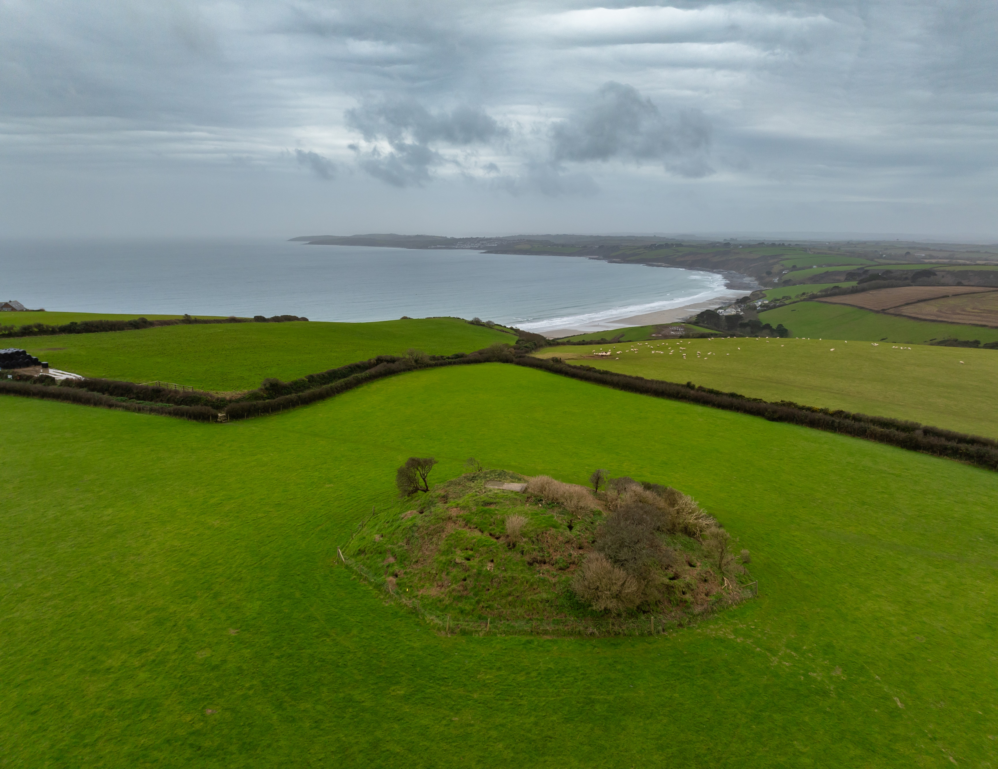

Carne Beacon Management Plan
A Monumental Improvement Project
Cornwall National Landscape
September 2025


A Monumental Improvement Project:

The Monumental Improvement Project was delivered by Cornwall National Landscape between 2022-2025 and sought to ensure that 40 at risk and vulnerable Scheduled Monuments, spanning 6000 years of Cornish history, were better identified, supported and enjoyed by a wide range of people.

The Project was funded by The National Lottery Heritage Fund (NLHF), Cornwall Council, Historic England, National Trust, Cornwall National Landscape (including Farming in Protected Landscapes Funding), Cornwall Heritage Trust, Cornwall National Landscape Trust.

The Project was supported by a Partnership Board, made up of representatives from Cornwall National Landscape, Historic England,
Cornwall Archaeology Society, Cornwall Heritage Trust, National Trust and Cornwall Council.

A Lasting Legacy:

The Purpose of this document is to provide advice and guidance on the future management of Carne Beacon. This management plan has been put together by the Monumental Improvement project and informed by the Partnership Board.

This document references the Toolkit for Volunteer Monitoring and Maintainance at Heritage Sites, designed to be used by landowners and volunteer groups in carrying out ongoing monitoring and maintenance, including a methodology approved by Historic England, ecological considerations, statutory designations, a reporting framework and risk assessment.

The Toolkit and resources including archaeological, ecological and management information, can be found on the site-specific webpages on the Cornwall National Landscape website.



Carne Beacon

Management Plan

Contents
Site Overview 3
Designations 4
Visiting & Contacts 5
Monumental Improvement Interventions 6
Management & Maintenance Recommendations: 7
Ongoing Site Management Recommendations: 7
Putting recommendations into practice: 8
Future Opportunities: 8
Vegetation/scrub clearance methodology: 9
Ecology Overview 9
Archaeological Overview (Taken from Historic England’s listing.) 10
Risk Assessment 12

Site Overview

(Use this information when completing HER Monument Monitoring and Recording form)

Site Name: Carne Beacon
Scheduled Monument Number: 1019745
Site Type: Round Barrow
Site Grid Reference: SW 91263 38647
Site W3W: archduke.dads.otherwise
Site Postcode: TR2 5PG
Details:
The barrow has a very prominent earth and stone mound, measuring approximately 40m in diameter and 5.5m high. Its profile is regular, with steep sides and a flat top some 11m across.

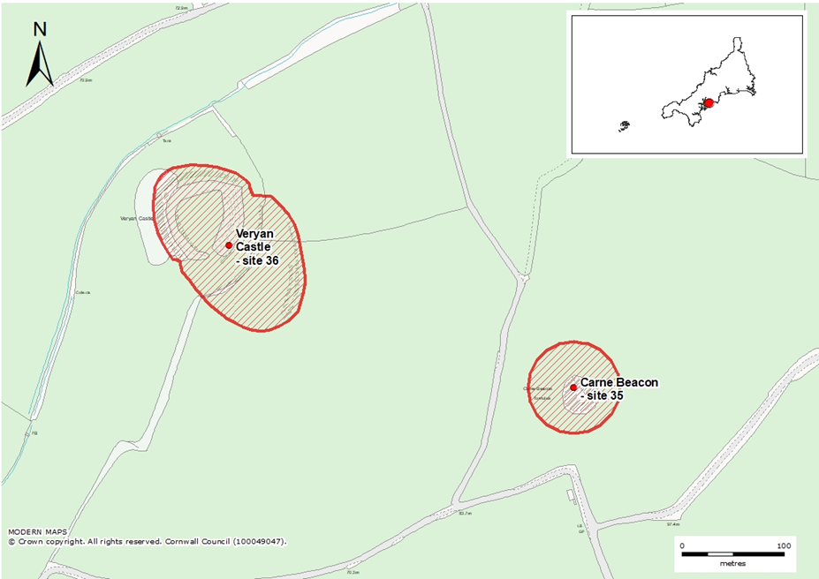

Designations

HE Designations: Scheduled Monument
Other Designations: Cornwall National Landscape – Section 9 – South Coast Central, Heritage Coast
Site Status on HAR register: At Risk

Link to CIOSHER web page for this site:
https://map.cornwall.gov.uk/website/ccmap/?zoomlevel=8&xcoord=191148&ycoord=38543&wsName=historic_natural_environment&layerName=Scheduled%20monuments

Link to Historic England’s webpage for this site:
https://historicengland.org.uk/listing/the-list/list-entry/1019745?section=official-list-entry

Link to Cornwall National Landscape webpage for this site:
https://cornwall-landscape.org/monument/carne-beacon/



Visiting & Contacts

Landowner (s): National Trust
Contact Email: sw.customerenquiries@nationaltrust.org.uk
Site Specifics –
Relevant Volunteer Organisation: National Trust HART Volunteers
Nearest Tool Hub: Tehidy Country Park
Tools Hub Contact: countrysideservice@cormacltd.co.uk
Tool Use: Hand tool only

Parking for site: Park considerately and carefully in Carne Beach National Trust Car Park see X in map below. NT members park for free (scan card at machine) NGR: SW 90553 38352 W3W: waiters.gurgling.divide
OR In layby in lane between Veryan and Carne Beach carpark
NGR: SW 91009 39049 W3W: clicker.skill.disband

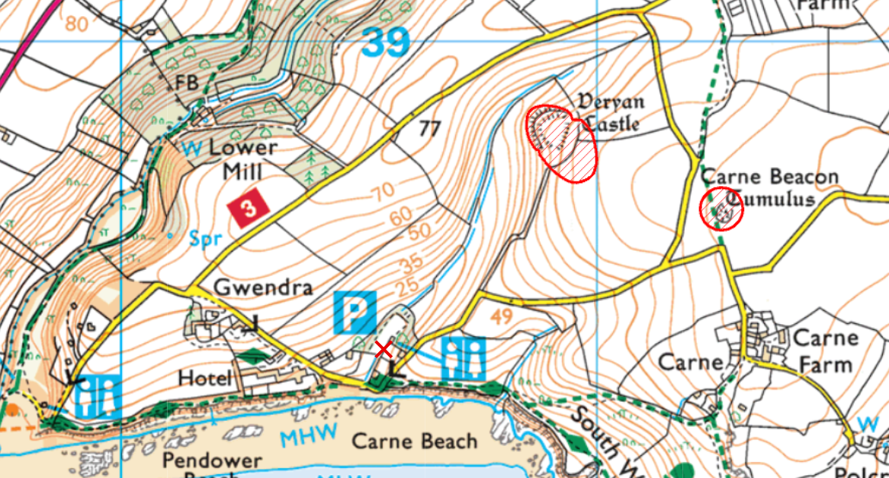

Monumental Improvement Interventions

Site priorities identified during Monumental Improvement Development Stage:

Priority | Project year | Action
Longer term | 3 (post project) | Volunteer monitoring of the site

Vegetation management | Interpretation | Survey & Monitoring
To be carried Sept/Oct out by CAS or local community groups | Landowner to check and report to Cornwall National Landscape on any issues | Monument Watch or HART monitoring through CAS or local community groups

Threats Identified at site:

- The principal threat to this site is the extensive badger setts and subsequent burrows.

Interventions during Monumental Improvement Delivery Stage:

- A condition survey was undertaken out in 2021 by Cornwall Archaeological Unit, identifying threats to the monument and proposing a range of interventions aimed at enhancing the condition of the site and raising its profile with the local community.
- An ecological survey of the site was completed in 2021 by Woodfield Ecology, identifying habitat types and compiling an inventory of notable species to inform future conservation and land management plans.
- New onsite interpretation panel.
- New gate and fence installed improving access to the monument.
- Badger survey completed with recommendations based on resolving damage caused by badgers and management of site, to best protect the monument whilst respecting the mammals who have made it their new home.
- Future management principles in this document were proposed based on conversations between the National Trust Archaeologist and the Monumental Improvement project team over the course of the project.
- Relevant Volunteer Organisation(s) have been engaged and supported throughout the Monumental Improvement Project. Volunteers have received hand tools safety training to assist in the future management of the site as part of the legacy programme.

Assets created during Monumental Imrprovement Delivery Stage:

- New site-specific webpage hosted on the Cornwall National Landscape website.
- New digital interpretation including a site overview, ecological information, surveys and reports.
- New on-site physical interpretation with a QR code for more information on the Cornwall National Landscape website.
- Aerial photography of the site captured by drone showing the archaeological features in plan.
- 360 panoramic photography hosted on the Cornwall National Landscape website allowing virtual tours of the site.
- Ground Photography of the site, recording conditions of the monument and its setting in the landscape.
- Creation of the Toolkit for Volunteer Monitoring and Maintenance at Heritage Sites to assist in the future management of the site.

Management & Maintenance Recommendations:

Ongoing Site Management Recommendations:

- Relevant Volunteer Organisation and Landowner to carry out periodic monitoring visits to the site focussing on the following threats to the site:
  - Signs of increased erosion of the path, particularly if there are archaeological deposits being revealed.
  - Landowner to consider works to repair the erosion or mitigate the impacts of foot traffic on the monument if identified as an issue.
  - The condition of the interpretation near the site.
- Develop long term badger strategy/feasibility study based on the following principles:
  - Option 1: Remove the fencing from the monument to minimise visual impact under archaeological supervision and conduct season vegetation clearance of the barrow to discourage the burrowing badgers. Vegetation will be left in the identified area BS3 (198 Badger survey) in an attempt to tempt the badgers to relocate of their own accord.
  - Option 2: Upgrade the fence to include sheep netting with narrow (<8cm) wire spacing with one-way gates for badgers to be able to leave the monument without returning. A chain mesh skirt to be fitted to the base of the fence running 1 metre externally to prevent badgers digging through the barrier. This skirt can be seeded to lessen visual impact.
- The Landowner to maintain relationship with any tenant farmer to understand the land use of the field surrounding the monument and provide recommendations or mitigation based on the Geophysical survey.

Putting recommendations into practice:

- Please refer to the Toolkit for Volunteer Monitoring and Maintainance at Heritage Sites for a best-practice guide to carrying out scrub clearance and monitoring work at heritage sites.
- All site work must be accompanied by a Risk Assessment covering all attendees and activities.
- A record of work should be made and a copy sent to the secretary of the Relevant Volunteer Organisations: e.g. Cornwall Archaeological Society, Historic England and Historic Environment Record (HER). You can find a template for your records and a link to the HER online form in the Toolkit for Volunteer Monitoring and Maintainance at Heritage Sites.

Future Opportunities:

- Opportunity to increase digital interpretation through the Cornwall National Landscape website.
- Further study of the nature and setting of the monument informed by the geophysical survey in the form of a desk-based assessment.
- There is a desire for the Landowner to lead a community excavation in the long term supported by the MI interventions at the site and focussed on the outer ditch. Historic England should be engaged to support this activity.

Vegetation/scrub clearance methodology:

Please refer to the Toolkit for Volunteer Monitoring and Maintainance at Heritage Sites for a best-practice guide to carrying out scrub clearance and monitoring work at heritage sites.

Ecology Overview

Taken from: ECOLOGY BRIEFING NOTE – SITE 35 CARNE BEACON BARROW
Commissioned by the Monumental Improvement Project in 2021

The full Report is available to download on the Cornwall National Landscape website and includes details on types of work likely affect the following species, a calendar for helping to plan work at the monument, and opportunities for ecological enhancement of the site.

Key species at this site:

Birds | Reptiles | Bats | Flora & Fungi | Invertabrates
Common Scoter  Cornish Chough  Mediterranean Gull  Purple Sandpiper  Slavonian Grebe  Velvet Scoter  Whitethroat | Adder  Common Lizard |  | Shore Dock

Archaeological Overview (Taken from Historic England’s listing.)

The barrow has a very prominent earth and stone mound, measuring approximately 40m in diameter and 5.5m high. Its profile is regular, with steep sides and a flat top some 11m across. An area at the centre and west of the mound top, however, has been disturbed and reduced in height by around 0.5m-1m. This is considered to result partly from an antiquarian excavation of 1855, which produced evidence of a central cist containing a cremation and several other cremations around this, although the appearance of the mound was said to have been restored afterwards. At the higher south side of this area is a World War II observation post, with a rectangular concrete platform measuring 4.1m north-south by 2.5m east-west and up to 0.4m high, with traces of a former superstructure. A stone faced boundary bank, forming an element of a post-medieval field system and considered to be medieval in origin, runs roughly north-south across the top of the mound east of centre. It is 1m wide and survives to 0.5m high. The visible length is 14m but it probably continues under the scrub on the steep sides of the mound. Aerial photographs show parts of two concentric buried external ditches, the inner ditch centred approximately 10m out from the mound base, and the outer ditch centred approximately 10m beyond the inner. By analogy with other round barrows, these are considered to be approximately 3m wide, and to encircle the whole barrow. A slight dip visible on the ground about 7m east of the mound may derive from the inner edge of the inner ditch (List Entry Number 1019745).

J.Gossip CAU Total Station Survey 2021: Carne Beacon

Risk Assessment

Before any work takes place, a comprehensive Risk Assessment should be created. A template has been prepared for work carried out at this site and should be updated for future events – with any new risks considered. The template can be found on the Cornwall National Landscape website and with the Relevant Volunteer Organisation.

Some key issues which should be included in a risk assessment:

- Uneven ground across the site including on the semi surfaced paths.
- Trip hazards including holes from burrowing animals.
- No toilet facilities nearby.

NB: This is not an exhaustive list and individual circumstances of each group and site conditions should be considered in creating a risk assessment.

